OOPS LAB

Experiment -9

NAME- ANMOL YADAV SAP ID- 500083814 ROLLNO- R214220178

**Question: 1**

Write a program to implement the concept of threading by extending Thread Class and Runnable interface

**Code:**

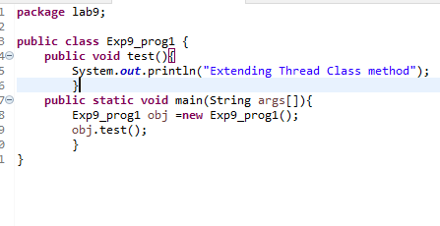

**Output:-**

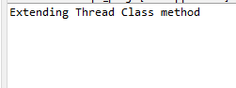

**Implementation using Runnable:-**

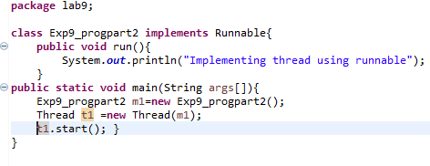

**Output:**

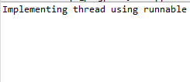

**Question: 2**

1. Write a program for generating 2 threads, one for printing even numbers and the other for printing odd numbers.

**Code:**

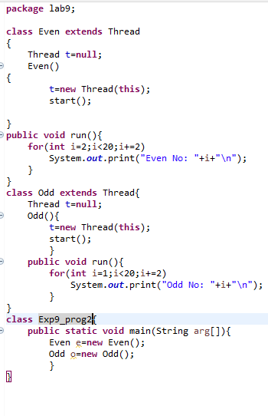

**Output:-**

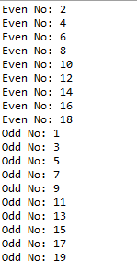

**Question: 3**

Write a program to launch 10 threads. Each thread increments a counter variable. Run the program with synchronization.

**Code:**

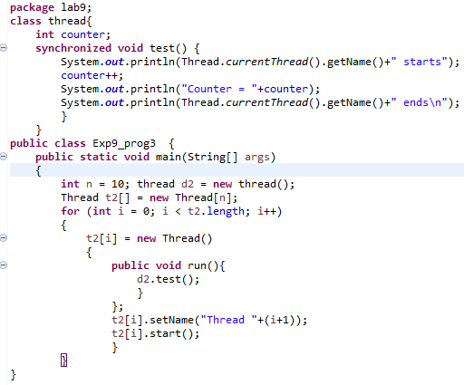

**Output:-**

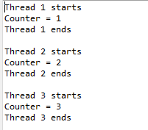

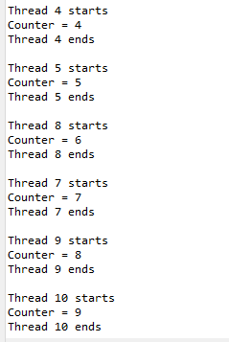

**Question: 4**

Write a Java program to create five threads with different priorities. Send two threads of the highest priority to sleep state. Check the aliveness of the threads and mark which thread is long lasting

**Code:-**

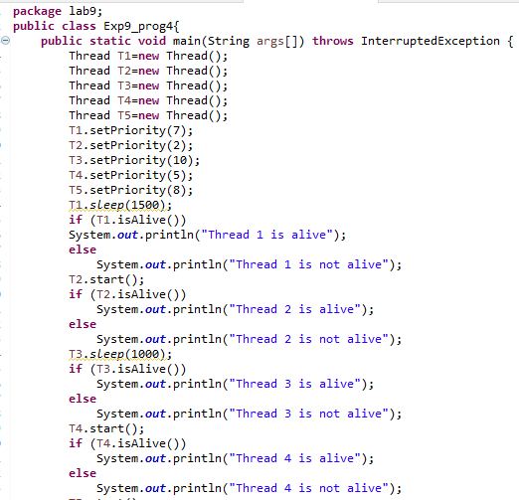

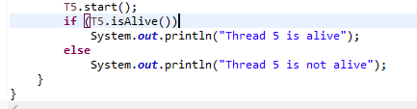

**Output:-**

